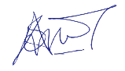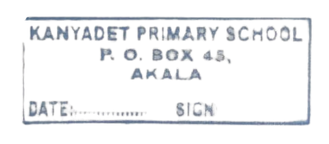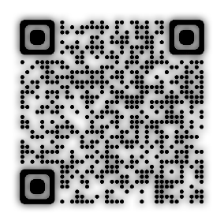



**KANYADET COMPREHENSIVE SCHOOL PERFORMANCE REPORT FOR GRADE 6 END TERM I THE YEAR 2025**

**PRINCIPAL’S REFLECTION**



**STUDENT NAME: OWAGA, PATRICK ODHIAMBO**

**CLOSING DATE: Friday 4th, April 2025**

**ASSESSMENT NO: A002764926**

|  |  |  |  |  |
| --- | --- | --- | --- | --- |
| **LEARNING AREAS** | **OUT OF** | **SCORE** | **LEVEL** | **TEACHER** |
| 1: MATHEMATICS | **30** |  | Below Expectation | MR AMBROSE |
| 2: ENGLISH | **40** | **9** | Below Expectation | MR OWUOR |
| 3: KISWAHILI | **40** | **11** | Below Expectation | MR VINCENT |
| 4: SCIENCE & TECH | **50** | **14** | Below Expectation | MR ODUOR |
| 5: CREATIVE ART | **50** | **11** | Below Expectation | MR OWUOR |
| 6: SOCIAL STUDIES | **50** | **11** | Below Expectation | MR MAXWEL |
|  |  |  |  |  |
|  |  |  |  |  |
|  |  |  |  |  |
|  |  |  |  |  |



The school will initiate a comprehensive support plan, including remedial sessions and progress monitoring, to elevate OWAGA, PATRICK ODHIAMBO's academic trajectory.

**School Stamp**

**CLASS TEACHER COMMENT**

<https://kanyadet-school-portal.web.app>

OWAGA, PATRICK ODHIAMBO is currently performing below the expected academic benchmarks. Targeted interventions and personalized support will be implemented to address learning gaps and foster improvement.

**OPENING DATE: Monday 28th, April 2025**

Below Expectation

**2-Mar-2025**